Project :
SMART RECYCLING WASTE CLASSIFIER
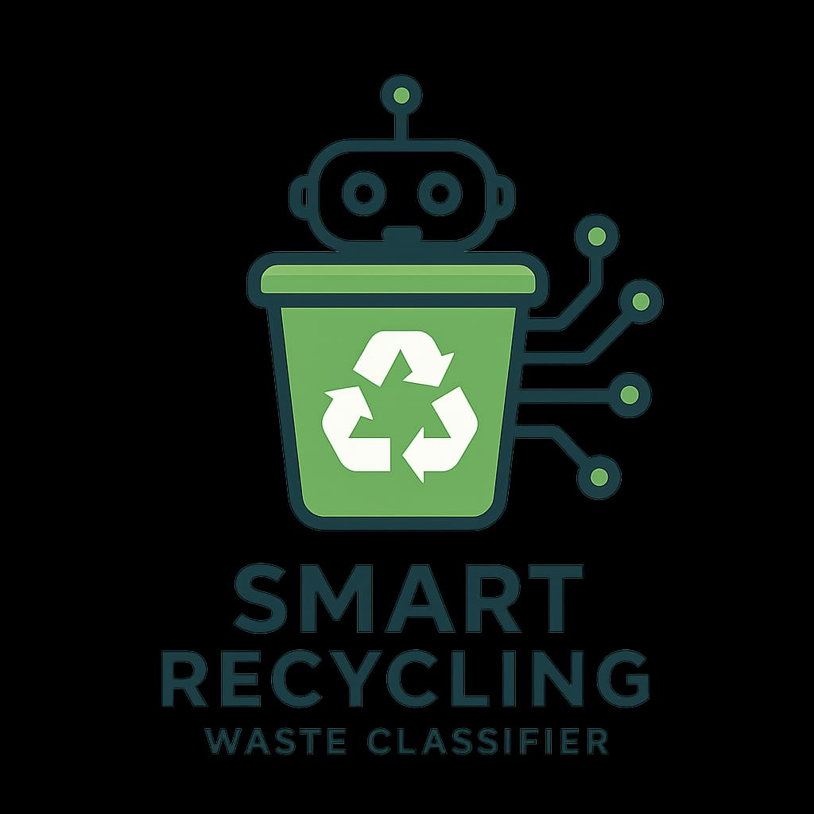

By Team – 13 :
V. Pardhiv – 246Q5A4201
P. Varshini – 236Q1A4202
B. Sri Venkata Sesha Sai – 236Q1A4209
B. Pranay Kumar – 236Q1A4212
Abstract :
- Waste is now a data problem as well as an environmental one.
- Smart Recycling Waste Classifier uses AI and sensor fusion to identify and sort waste.
- Learns from disposal patterns to improve accuracy over time.
- Can recognize complex waste mixtures missed by traditional systems.
- IoT connectivity enables real-time monitoring, predictive analytics, and user feedback.
- Reduces landfill use and transforms waste into a measurable, manageable resource.
- Supports a data-driven, proactive recycling approach in line with the circular economy and sustainability goals.

Introduction :

- AI-Powered Recognition accurately identifies various waste types using machine learning and computer vision.
- IoT Connectivity enables real-time monitoring and smarter waste management.
- Automated Sorting reduces human error and improves efficiency.
- Data Analytics offer insights into waste patterns for better planning.
- Cost-Effective system lowers labor and operational costs while boosting recycling revenue.
- User-Friendly Design includes smart alerts and an intuitive interface.
- Sustainability Focus aligns with global environmental goals like the UN SDGs.
- Future-Ready for integration with smart infrastructure and circular economy systems.

Project Overview :
The Smart Recycling Waste Classifier transforms waste management into an intelligent, data-driven system. By using AI, sensors, and IoT, it actively identifies and sorts waste into recyclable, organic, and residual categories. Unlike traditional passive bins, it learns, adapts, and communicates, making it suitable for homes, public spaces, institutions, and industries. This turns waste from an afterthought into a key part of a smart, sustainable ecosystem.

Project Purpose :
- Enhance accuracy in waste segregation using machine learning.
- Support the circular economy by maximizing material recovery and reuse.
- Reduce landfill use to lower environmental impact.
- Enable data-driven decisions with waste analytics for organizations and cities.
- Promote responsible behavior through real-time feedback and education.
- Build future-ready systems that scale and integrate with smart technologies and sustainability efforts.
Technologies can be used :
1. Artificial Intelligence (AI) & Machine Learning (ML)
Deep Learning Models (CNNs, ResNet, EfficientNet, MobileNet) for image-based waste recognition. Transfer Learning to reuse pre-trained models on waste datasets. Reinforcement Learning for improving classification through feedback.
2. Computer Vision Image Recognition & Object Detection using OpenCV, TensorFlow, PyTorch, YOLO, Faster R-CNN. Segmentation (e.g., Mask R-CNN, U-Net) for detecting waste in cluttered/messy environments. Edge AI Models optimized for deployment on IoT devices.
3. Internet of Things (IoT) Smart Bins with cameras, weight sensors, ultrasonic sensors (to detect bin fill-level). Moisture & Gas Sensors for distinguishing organic/biodegradable waste. Connectivity: Wi-Fi, LoRaWAN, Zigbee, or NB-IoT for real-time monitoring and data transfer.
4. Robotics & Automation Robotic Arms & Conveyor Belts for automatic sorting in recycling plants. Actuators & Servo Motors in bins to direct waste into correct compartments. Embedded Controllers: Arduino, Raspberry Pi, NVIDIA Jetson, ESP32 for local processing.
5. Cloud & Big Data Cloud Platforms: AWS, Google Cloud, Microsoft Azure for large-scale data storage and processing.
Big Data Analytics: To analyze waste generation patterns and optimize recycling strategies. APIs & Dashboards for smart city integration and user feedback.
6. Sensors & Hardware Technologies Load Cells → Measure waste weight.
Infrared (IR) & Near-Infrared (NIR) Sensors → Detect plastics and material composition.
RFID Tags & QR Codes → For tracking recyclable items.
Solar Power Units → For sustainable, self-powered smart bins.
7. Data Science & Analytics
Predictive Analytics → Forecast waste generation trends.
Pattern Recognition → Identify waste habits at individual, community, or city level.
Optimization Algorithms → Improve waste collection routes and recycling efficiency.
8. Human-Machine Interfaces (HMI)
Mobile & Web Apps → For user notifications, bin status, and recycling guidance.
Smart Displays → On bins to guide users during disposal.
Gamification → Reward-based apps encouraging responsible recycling.
DataSet can be used :
1. TrashNet Dataset
Content: ~2,500 images across 6 categories (plastic, paper, glass, metal, cardboard, trash).
Use: Benchmark dataset for initial training of classifiers.
Limitations: Small size, clean lab-like images (less real-world variation).

Conclusion :
The Smart Recycling Waste Classifier shows how combining artificial intelligence, computer vision, and IoT technologies can change traditional waste management into a more efficient and sustainable system. By automating waste identification and sorting, the solution reduces human errors, cuts down on landfill use, and improves recycling efficiency. Its ability to learn and use sensor data allows for accurate classification in real-world situations. This makes it suitable for homes, institutions, industries, and smart cities. Additionally, the system can provide real-time data and insights

